*Which books did Marcus Thint write in 2010 ?*

<Marcus Thint, write, books>

< books, in, 2010>

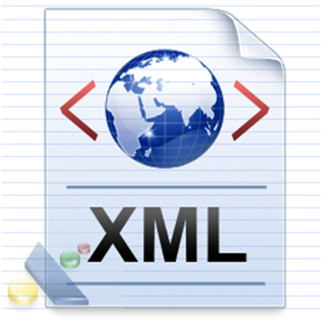

*XML config file*

write

in

*Which books did Marcus Thint write in 2010 ?*

<(Author)Marcus Thint, write, (Publication)books>

<(Publication)books, in, (Year)2010>

